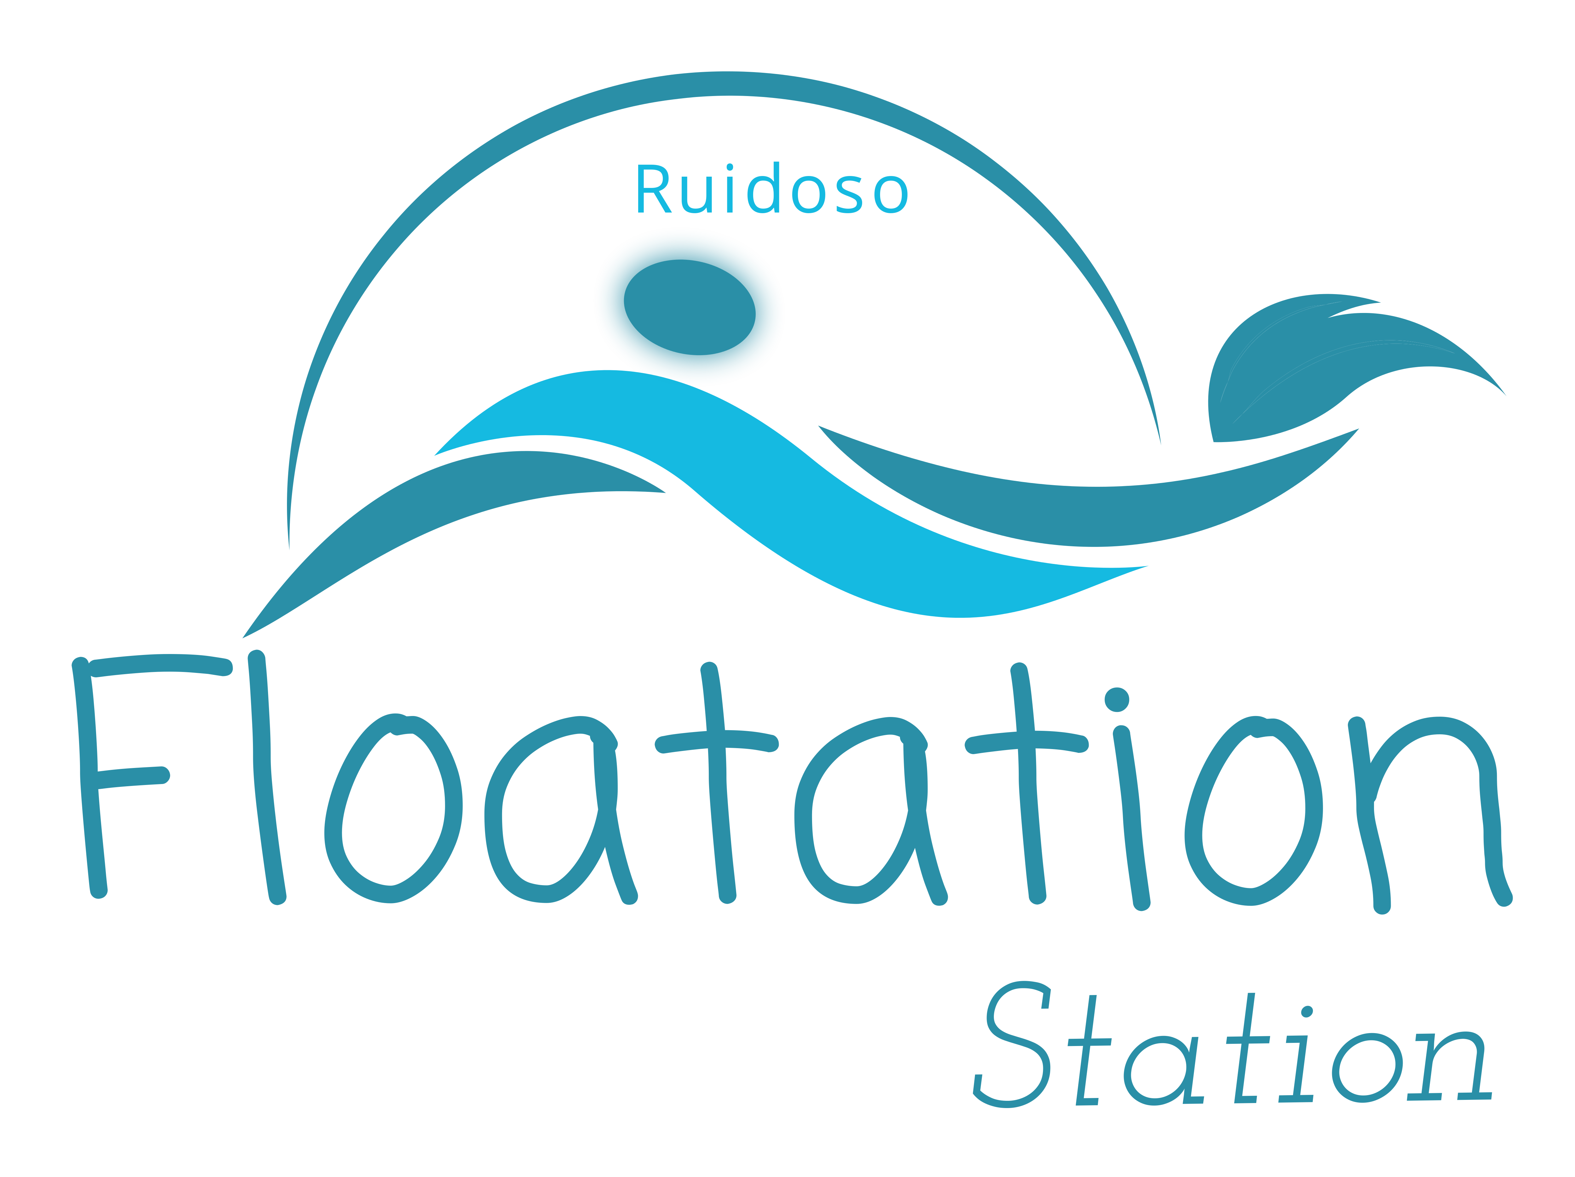

Name Date
Address:
Phone: Alternate Phone:
Email: Birth Date:
Emergency Contact: Relationship:
Emergency Contact Phone:

How did you hear about us?

What is your main reason for floating?

This basic health questionnaire will help insure the safety and well being of our clients using the Floatation Station Float Pods.

Have you consulted your doctor prior to making appointment if you have any of the followings conditions? Yes No

Heart Trouble Require assistance due to limited

Chest Pain mobility, bone or joint problems
Epilepsy High Blood Pressure

Major Surgery in last six months Anxiety Disorder

Cancer Treatment in the last six months Diabetic

Please list any medical conditions/treatments, past or present not mentioned is this questionnaire that you may feel we should be made aware of :

Professional Disclosure and Agreement

Facilities: Amenities provided include: robe, towel, washcloth, ear plugs, petroleum jelly, shampoo/conditioner/body wash, and shower. It is up to the individual to take caution to prevent slipping or falling, as floor surfaces may be wet. The facility is cleaned and maintained between each session. Additionally, the pod is filtered and sanitized between each session in accordance with the Float Tank Community Standards and will uphold all standards of the National Floatation Tank Association and the New Mexico Environment Department.

Fees: Sessions are generally 60-90 minutes depending on desired float time. Fees vary based on desired service package. These fees are subject to change.

Cancellations/ Late Fees: We kindly request that you notify us 24 hours in advance. If 24 hour notice is not given client will be subject to a $40.00 fee. If a client is late for an appointment the clients float time will be shortened to accommodate scheduled floaters if necessary.

Over
Contraindications and Floating Agreement: We want to provide you with an amazing experience that is safe. Please read the following as your agreement to help us uphold this to all of our floaters. Please initial here for Agreement______________________.

- Clients are REQUIRED to shower prior to entering the pod
- No freshly dyed hair two weeks), henna, tattoo’s allowed in the pod
- If you suffer from any communicable condition, infectious disease or skin condition you may not be allowed to use the pod
- If I am an epileptic (unless seizures are under control and was approved by my doctor)
- You must not be under the influence of any drugs or alcohol.
- Women on their menstrual cycle will not be allowed to float and will need to reschedule.
- Avoid Caffeine two hours prior to your float, be sure to eat a little something.
- If a client contaminates the pod in any way, they will be required to pay a cost of $500 to clean up and refill the pods.
- Minors must be accompanied by a parent or legal guardian and sign this waiver.
- All first time floaters are required to watch a short video on floating.

Safety Agreement: I am choosing to use the floatation pod of my own free will and will not hold owner/operator or Floatation Station, LLC liable for any claims, damages, actions (or cause of actions) within the float spa or while on the premises.

I have read and understand all above.

Client Name Client Signature/ Parent or Legal Guardian

Date Witness

